TLM background measurements
  - Introduction
In considering the design of an electrometer for TLMs, the expected background signal needs to be taken into account. The background counting rate is sensitive to recent events including bias supply voltage changes and gas ionization caused by beam loss.
The purpose of this paper is to document observations of TLM background where the heartbeat resistor is not employed. These observations will be useful when evaluating of the effectiveness of the TLM heartbeat resistor.
  - Background During Extended Periods with No Beam Loss
A series of background measurements was made using the chipmunk electrometer for the 125’, 250’, and 338’ TLMs over extended periods of time with no beam present. The results of these measurements are shown in Figures 1, 2, and 3. The data presented are one minute integrals of TLM charge collected by a Chipmunk electrometer. As can be seen in the Figures, the background charge collection rate does not vary significantly among the three cable lengths. The background rate tends to be less than about 150 pC/minute.
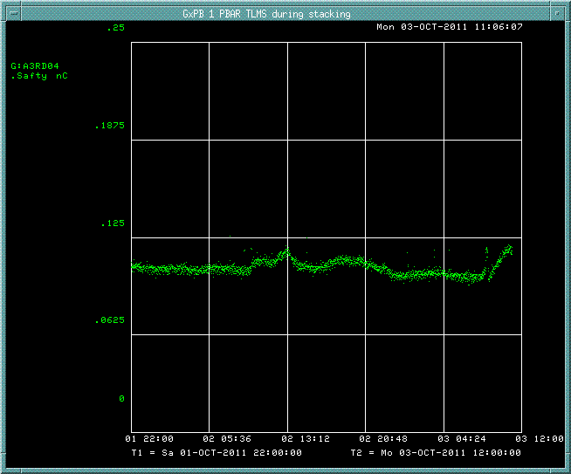
Figure 1: 125 foot TLM background over 38 hour period on blue box with bias voltage at 500 volts. Units are nC/minute.

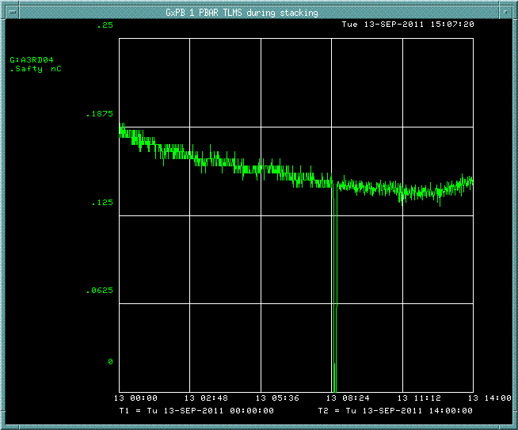
Figure 2: 250 foot TLM background collected over 14 hour period with no beam with bias voltage at 500 volts. Units are in nC/minute.

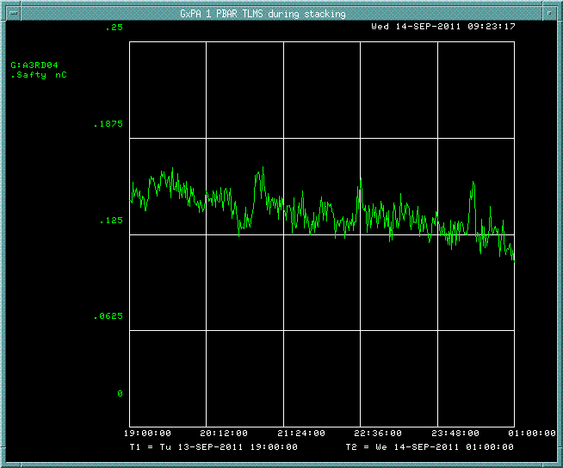
Figure 3: 338 foot TLM background on the blue box over 6 hour period with no beam with bias voltage at 500 volts. Units are nC/minute.

  - Background During Periods with Beam Loss
The response of TLMs to an intentional, controlled 8GeV beam loss at a designated location (A2B7 in the Accumulator) has been determined for a number of TLMs including 10’, 125’, 250’, and 338’ lengths. The measurements were conducted by applying various DC bias voltages to the outer shield of the Heliax cable while monitoring a signal on the center conductor. Argon was used as the chamber gas and was continuously purged through the cable at a flow rate of approximately 50 cc/min. The results of the TLM response to the controlled beam loss are reported elsewhere.
A Labview script was used to record the integrated charge on the Keithly 6517B electrometer at one second intervals over a period of up to 100 seconds. The beam loss was instantaneous and all the resulting charge from gas ionization was collected in less than 1 second. The TLM background rate is determined simply by taking the average of the differences between subsequent data points. For purposes of the background analysis, several data points around the beam loss event are ignored. A typical measurement is shown in Figure 4.

Figure 4: Integrated charge as function of time during a beam loss event in nC. The background counting rate (in pC/s) is the difference in electrometer reading at 1 second intervals over the 100 second sample data set. The beam loss occurs at about 16 seconds into the sampling period. The average of the background counting rate for this measurement is about 23 pC/s or 1,380 pC/minute.
The background counting rate was determined for each of the four TLM cable lengths at 3 different beam intensities over a wide range of TLM bias voltage. Figures 5 through 8 show the background counting rates under the various conditions for each of the TLM cables.

Figure 5: 10 foot TLM background component measured during various beam losses at a known location.

Figure 6: 125 foot TLM background component measured during various beam losses at a known location.

Figure 7: 250 foot TLM background component measured during various beam losses at a known location.

Figure 8: Limited data set is available for 338 foot TLM. Most of the response checks to beam loss were conducted earlier in the TLM development effort using a different technique. Results for 8 bunches up to 600 volts are similar to other lengths of TLM.
Background signal is significantly larger during periods when beam loss occurs compared with extended periods of no beam loss. The background response changes is variable and depends loosely on the intensity of beam loss. It appears that residual charge collected from the TLM cable is directly related to the amount of ionization that occurs during a given quantity of beam loss; additionally the charge released has an associated time constant that is independent of the amount of ionization produced.
Based upon TLM plateau measurements, a bias voltage of 500 volts should give a linear response over a wide range of beam loss scenarios. The expected background as a function of beam loss can be estimated. Figure 9 shows the local background rates with a bias of 500 volts over a 2 decade range of beam loss.
Target background rate
Figure 9: Background summary for beam loss on various TLMs with applied bias of 500 volts. The indicated number of protons were lost 7 to 8 times per hour, limited by the data taking rate for the measurements. Background rates can be expected to scale with actual beam loss for TLMs without a heartbeat resistor. The target heartbeat background rate is indicated by the red line in the chart.
  - Discussion
A predictable background counting rate is a very important indicator of a counting system performance. The chipmunk ion chamber used at Fermilab is typically equipped with a radiation source (Cs-137) which results in a very constant/consistent background counting rate over a wide range of environmental conditions. In effect, the source provides a current bias in the chamber which leads to a very stable, reliable background signal.
We plan to use a very high impedance resistor between the HV outer conductor and the central signal conductor to enforce a current flow which would serve as a heartbeat for the TLM. It is envisioned that the selection of an appropriate size resistor will lead to a low, stable and predominant leakage current that may reduce or eliminate background variation. The resistor would need to be sized such that the background counting rate is significantly lower than the lowest signal which is required to be detected.
A requirements document has been written for the TLM dynamic range. The minimum trip signal has been determined to be about 30 nC/minute. A signal to noise ratio of 10:1 would require a background signal of about 3 nC/minute. Assuming a 500 VDC bias voltage is used, a 3 nC/minute background could be achieved with a 10 Tohm resistor.
$$R=\frac{V}{I}$$
$$R=\frac{500 volts}{3 nC/minute}=10 Tohm$$
The heartbeat signal to background current ratio is also an important consideration. One would like the variation of the background signal around 3 nC/minute to be reasonably low. The mu2e beam delivery is to be sixteen 1E12 proton pulses every 1.33 seconds. Anticipated beam losses during operation must remain very low (<< <1%) in order to control radiation dose rate inside of the Delivery Ring service buildings.
The TLM response measurements were made using about 8 beam pulses per hour at the intensities shown in Figures 5 through 8. The 1 turn 80 bunch beam loss was about 3.7E11 protons per pulse. At 8 pulses per hour, the beam power is about 1 watt. The resulting background associated with level of beam loss might be on the order of 1 to 2 nC/minute. The actual background behavior may be very different when a heartbeat resistor is used. This behavior will be examined in subsequent TLM tests.

